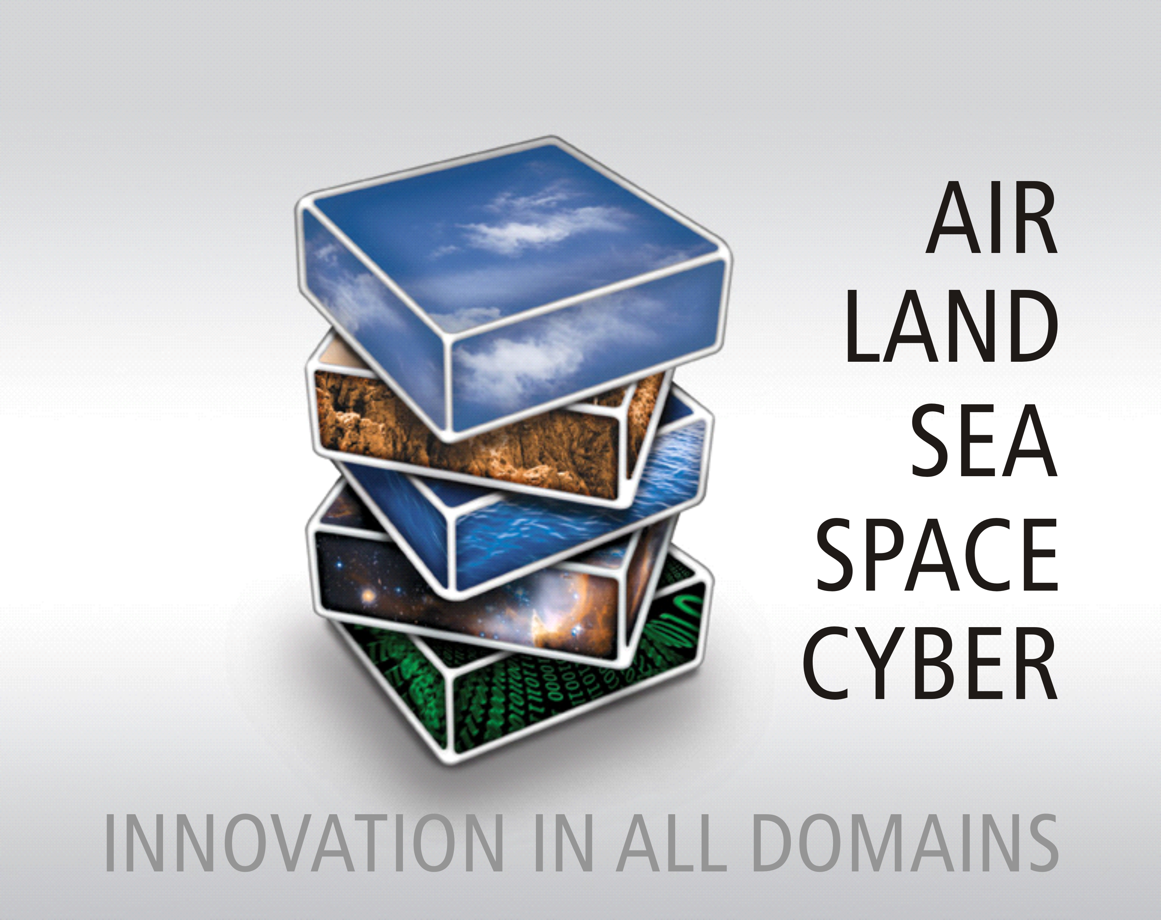

INCOSE Tutorial (12th June)

Model Based Systems Engineering for large-scale software based programmes

Presenters
Felicity Fashade
Phil Wilson
Paul Lowe

Contents
1 Raytheon UK Background 4
2 Tutorial Summary and Learning Objectives 5
3 Tutorial Overview 6
4 Course Notes 7
5 Accelerated and Integrated Development (AID) Methodology Diagram 56
6 Example Artefacts: i.e. Use Cases, Activity Diagram, Sequence Diagram, Domain/Data Model, UI Wireframes 59
6.1 Conceptual Design 59
6.1.1 Requirements 59
6.1.2 Use Cases 62
6.1.3 Data Models 63
6.1.4 Activity Diagram 65
6.1.5 Logical Sequence Diagrams 66
6.1.6 User Interface 69
6.2 Solution Design 70
6.2.1 Physical Data Model 70
6.2.2 Sequence Diagram 71
6.2.3 Deployment Model 72
6.2.4 Standards View 73
7 Glossary of Terms: 74
8 References 74
9 Biographies of Presenters: 75
10 Name and contact details of the presenters 76

Raytheon UK Background
Raytheon UK is a wholly-owned subsidiary of Raytheon Company and in the UK has a history of innovation spanning more than 100 years.
As a major supplier to the UK Ministry of Defence, the company as developed strong capabilities in mission systems integration with defence, national security and commercial markets. Raytheon designs, develops and manufactures a range of high-technology electronic systems and software at its facilities in Harlow, Glenrothes, Uxbridge, Waddington and Broughton.
With 1,200 employees at sites across England, Scotland and Wales, Raytheon UK is currently executing more than 200 programmes across ISTAR, ATMS, complex weapons, power, cyber and training domains.
Raytheon UK delivers innovative, affordable, integrated solutions to customers in the UK, Europe, Middle East and Africa based on the ability to integrate indigenous UK capabilities with proven US solutions.
Raytheon UK is one of the first companies worldwide to achieve BS11000 Partnering and Collaborative working standard, reinforcing our proven track record in sustainable collaborative relationships.

Tutorial Summary and Learning Objectives
Learning Objectives:
At the end of the Tutorial, the participants should:
- understand the "Accelerated and Integrated Development" methodology flow
- gain a good insight into the design artefacts including traceability and linkages required to support the methodology
- be able to tailor and adopt the methodology in their own design and development environment.
Title:
Model Based Systems Engineering for large-scale software based programmes
AIMS AND OBJECTIVES OF THE TUTORIAL/WORKSHOP:
A tutorial to describe the tools and the “Accelerated and Integrated Development” methodology developed by Raytheon UK to use in designing, developing and testing large software based programmes.
The tutorial will describe the steps involved in:
- Developing the design using multi-disciplined functional streams and a UML based approach
- High Level architecture approach to identify key internal and external interfaces, the interoperability between functional streams, assumptions and constraints of the system, ensuring a coherent design by all the functional streams
- The structure of the design model to show traceability and linkages.
The tutorial will not cover in detail the capturing and analysing of customer requirements, or the approach to testing which uses model artefacts, leading to sell-off of the customer requirements, linkages to these significant steps will however be identified.

Tutorial Overview
The tool selected to illustrate the defined methodology is Enterprise Architect (EA). An example project with a set of defined customer requirements, including all contractual documentation such as the Statement of Work will be used to demonstrate how the requirements are imported into the design tool EA, to allow traceability to the design model.
Prior to developing the UML design model, a full analysis of the requirements will have been carried out to identify the main functional streams of the system (It is also recommended at this stage, for a multiple release strategy, to identify the association between key functions and their required delivery dates, to allow for software build and release planning). Subsequently, a set of functional and non-functional requirements are allocated to each of the functional streams.
The design activities are then performed on a stream by stream basis, with each stream concurrently developing their designs in accordance with the high level architecture identified. Regular communication between the streams is essential to maintain consistency in the design, and in cross-stream artefacts.
The tutorial will walk through the full UML system design model in EA, artefact by artefact, to describe why they are needed and how they trace to each other and the requirements. These artefacts include use cases (The use of a RACI (Responsible, Accountable, Consulted, Informed) chart will help to identify the “actors” for each use case), activity diagrams, sequence diagrams, logical data model, user interface wireframes. When developing use cases, it is also vital to ensure that the end users requirements are fully captured and any assumptions are clearly understood and risks are identified if necessary.
The tutorial will conclude how the model artefacts can be used to develop the test strategy followed by a team discussion on how the overall methodology can be changed to increase efficiency or adapt for other programmes. This methodology is not a “fit for all” design methodology, but has rather evolved through actual project experience, and as such is open to improvement. Also, different architecture frameworks used/mandated by the Customer will result in different design artefacts being produced. Potentially, different modelling tools can also be used to fit in with the same methodology.

Course Notes
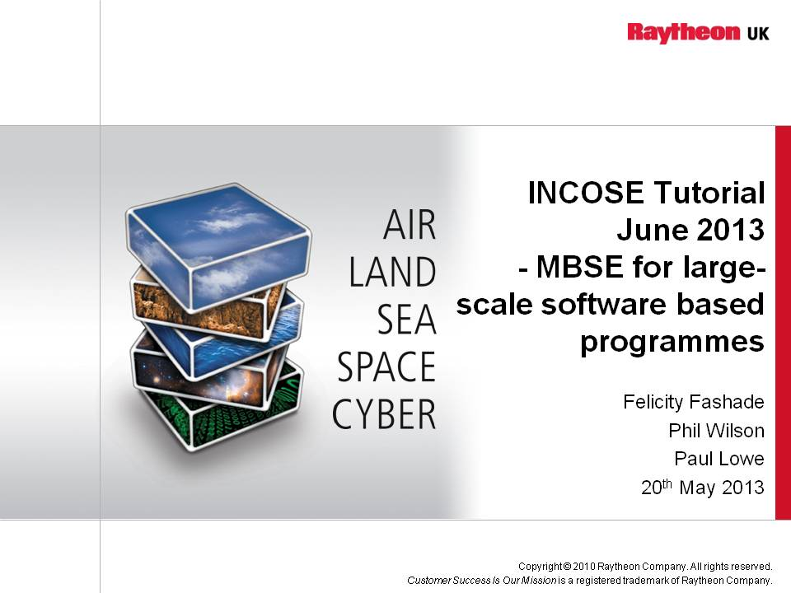

Notes

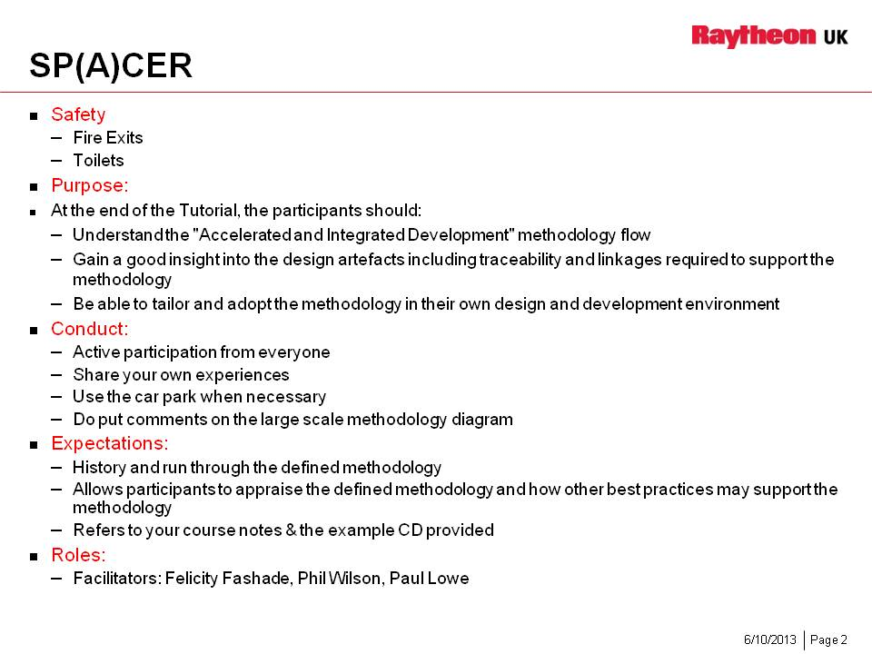

Notes

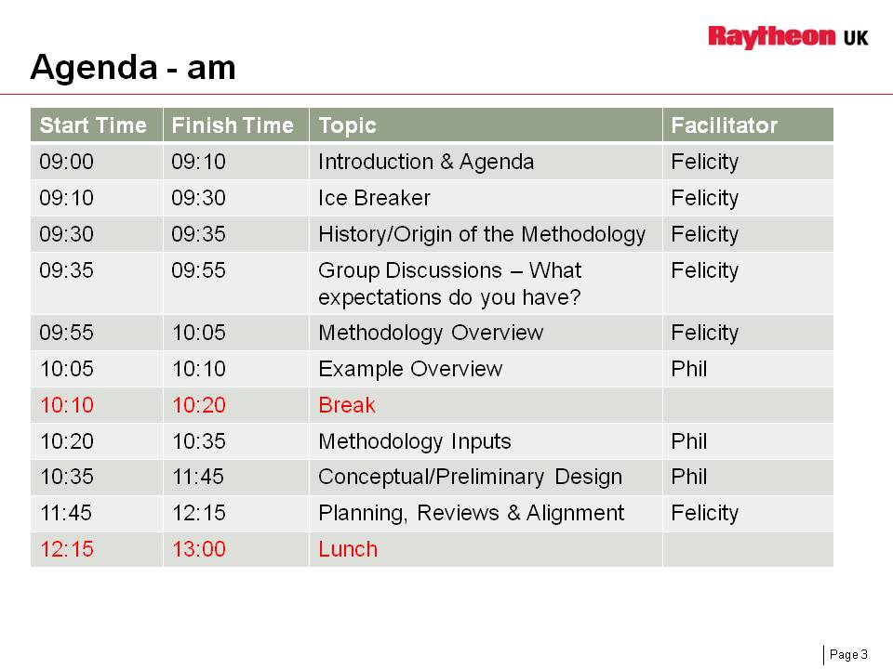

Notes

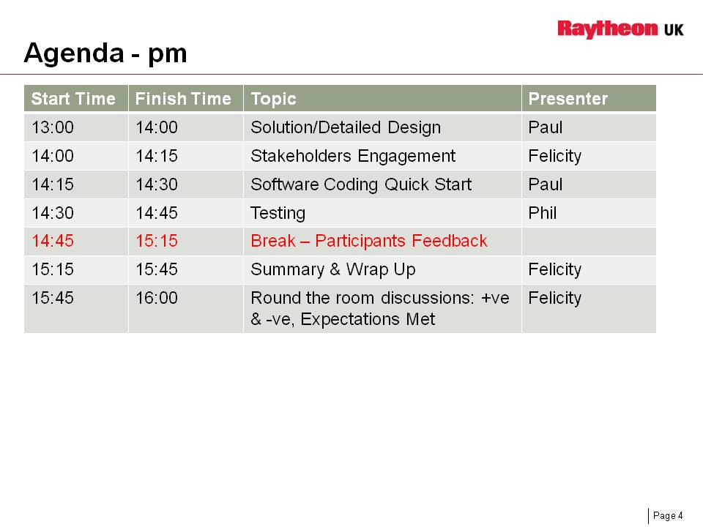

Notes

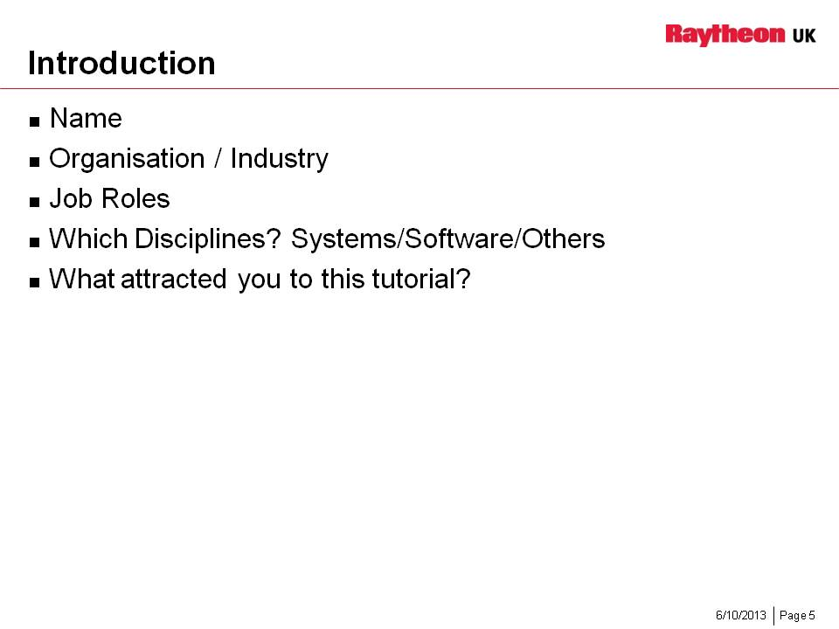

Notes

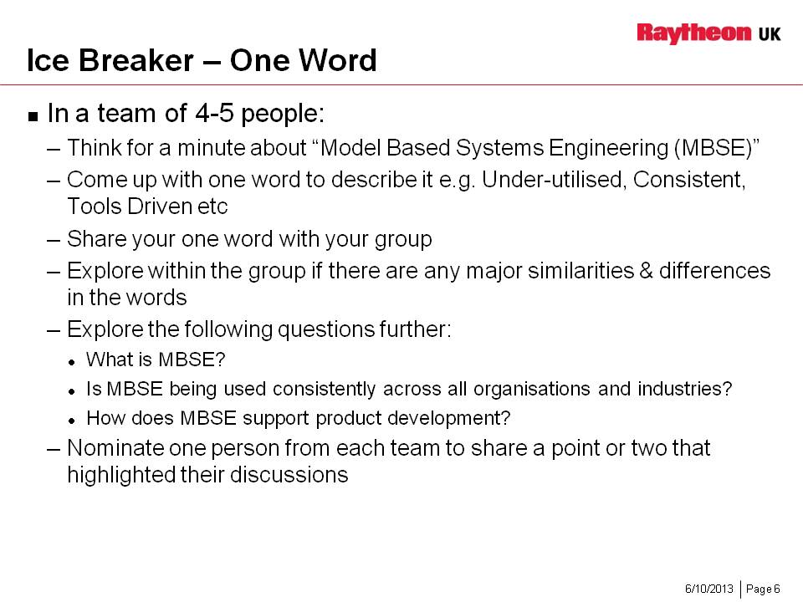

Notes

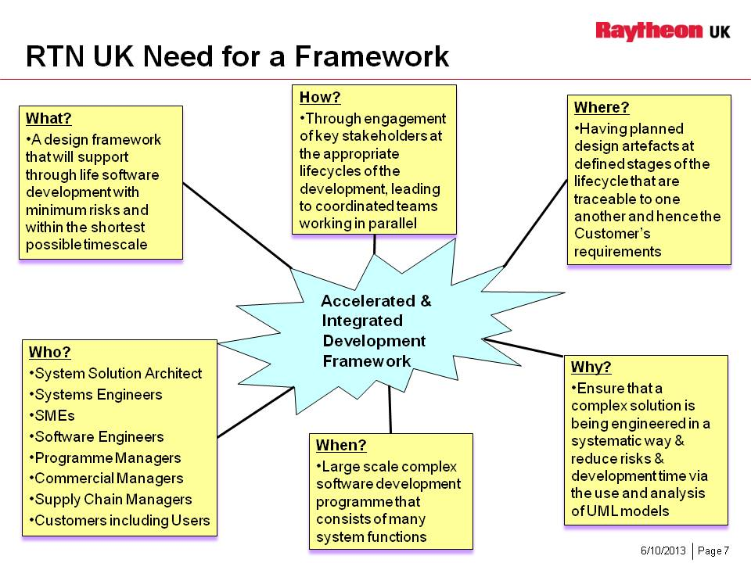

Notes

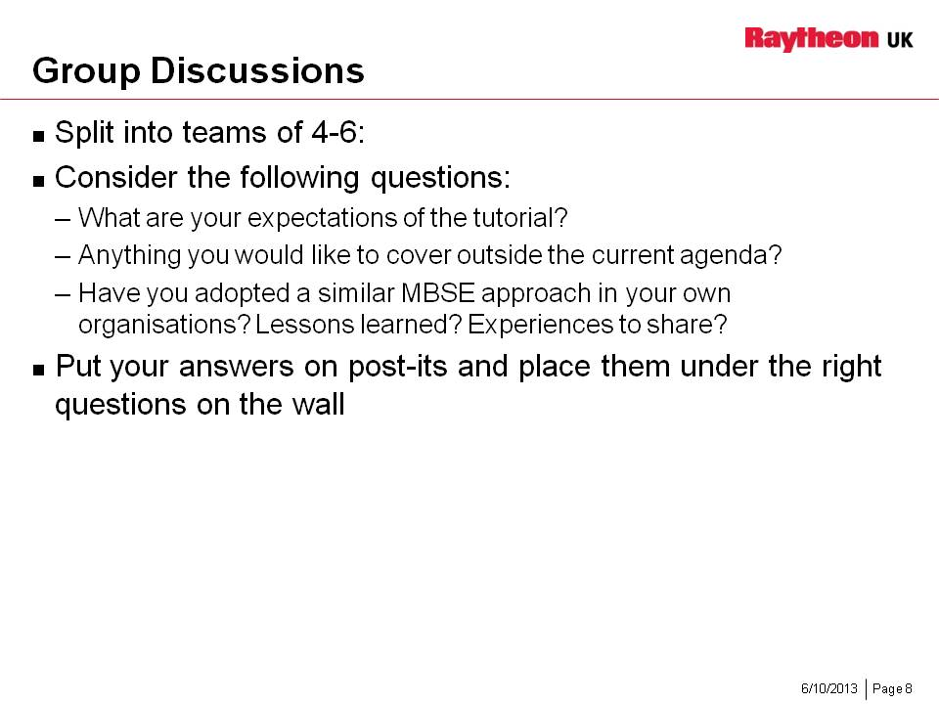

Notes

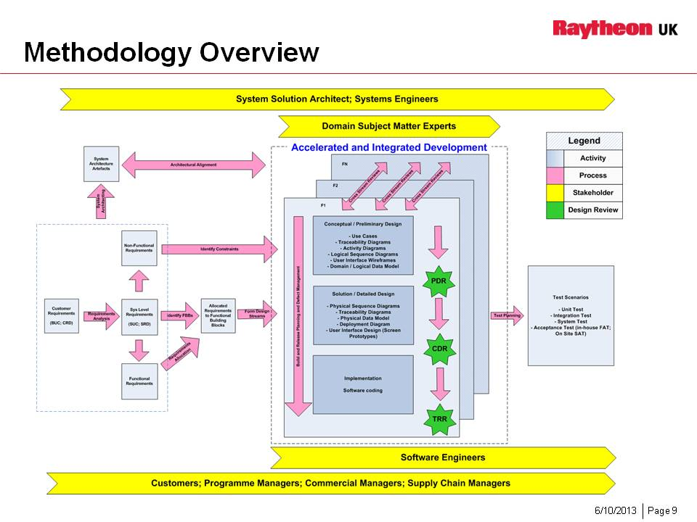

Notes

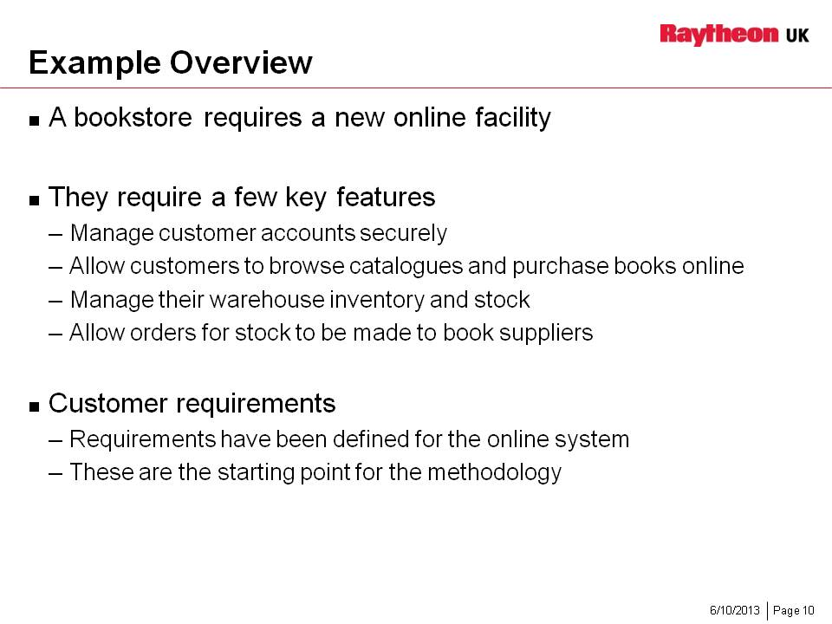

Notes

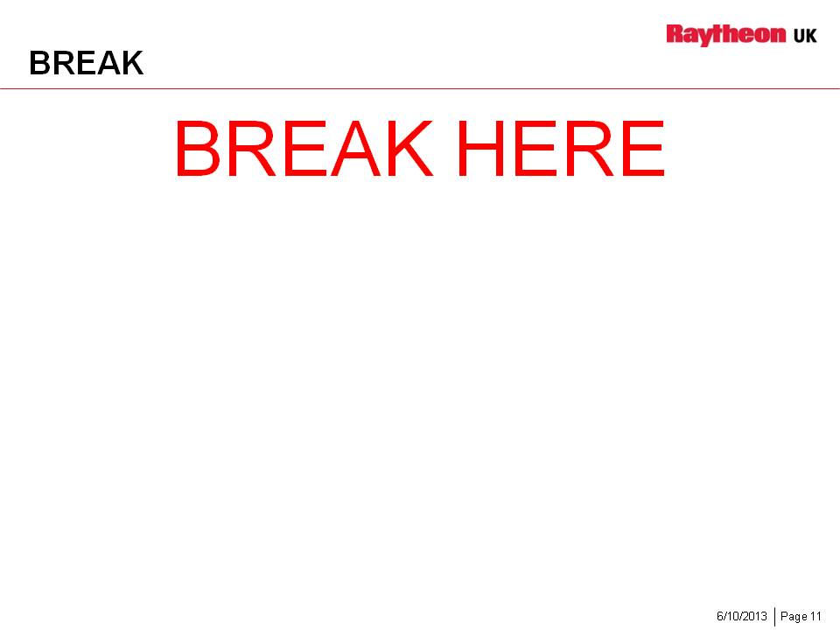

Notes

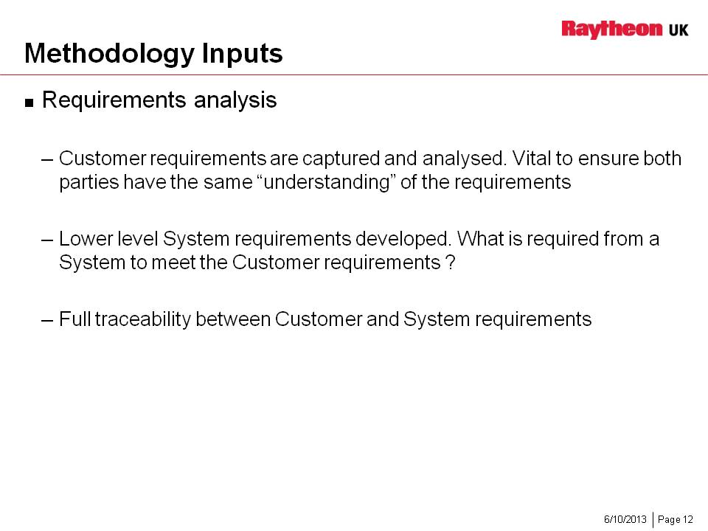

Notes

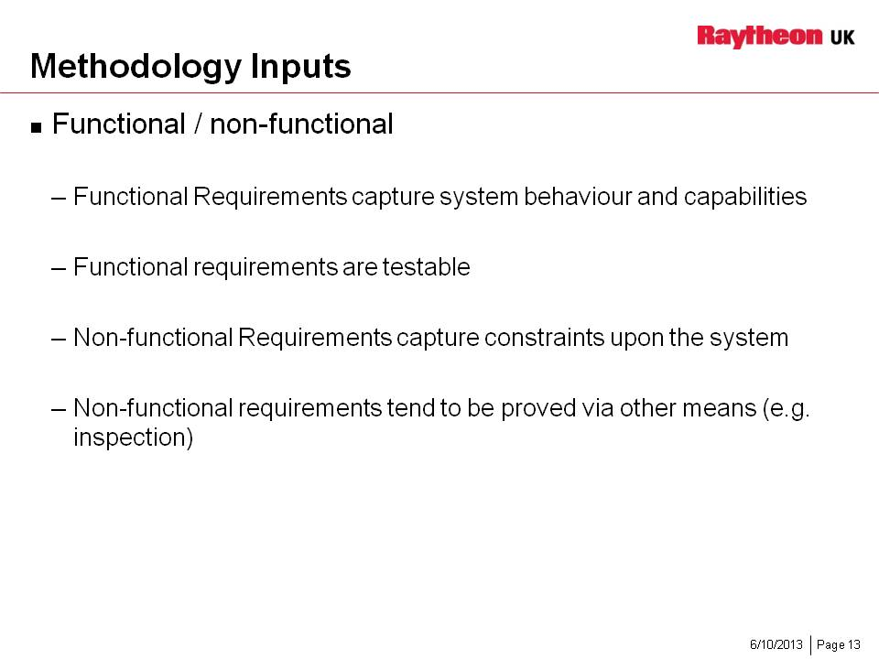

Notes

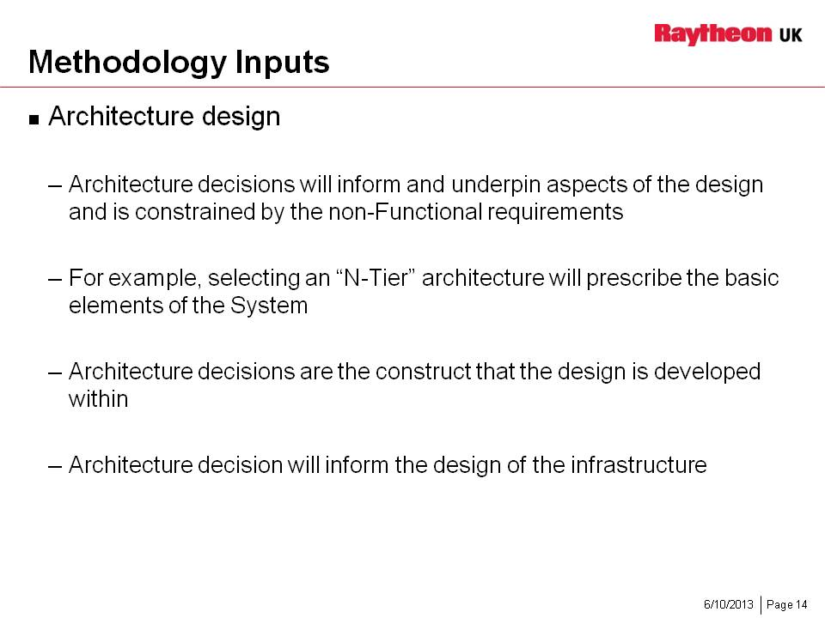

Notes

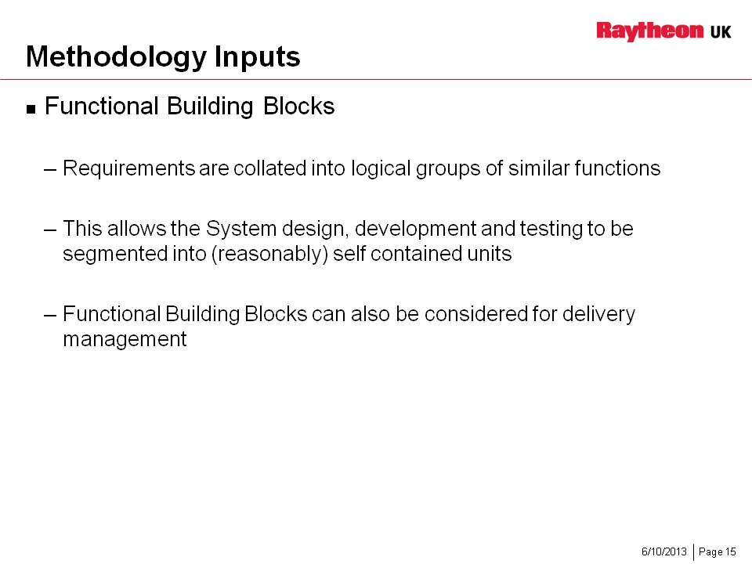

Notes

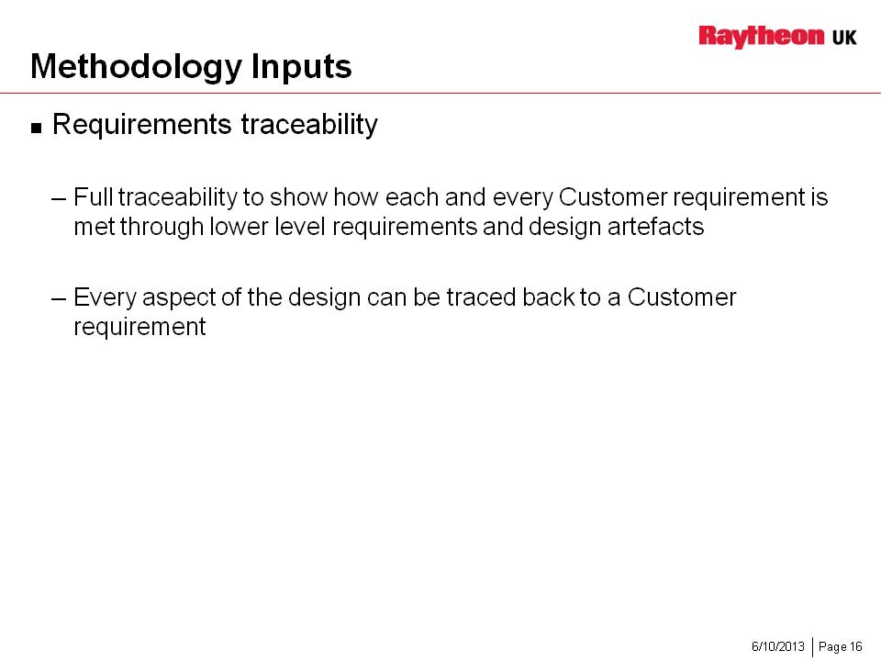

Notes

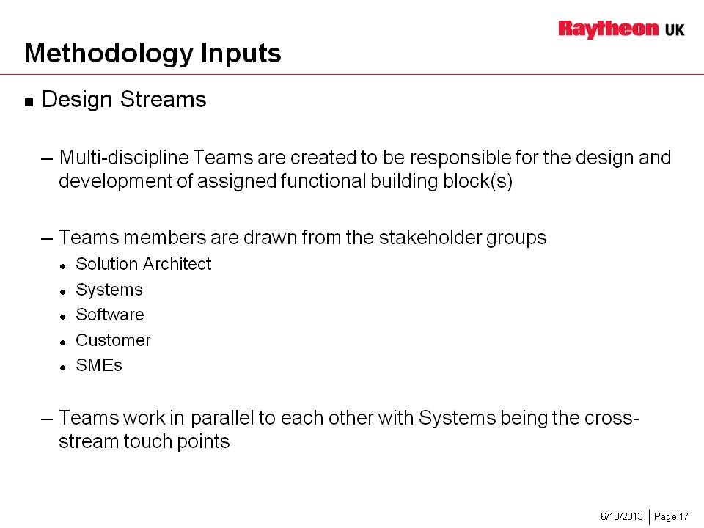

Notes

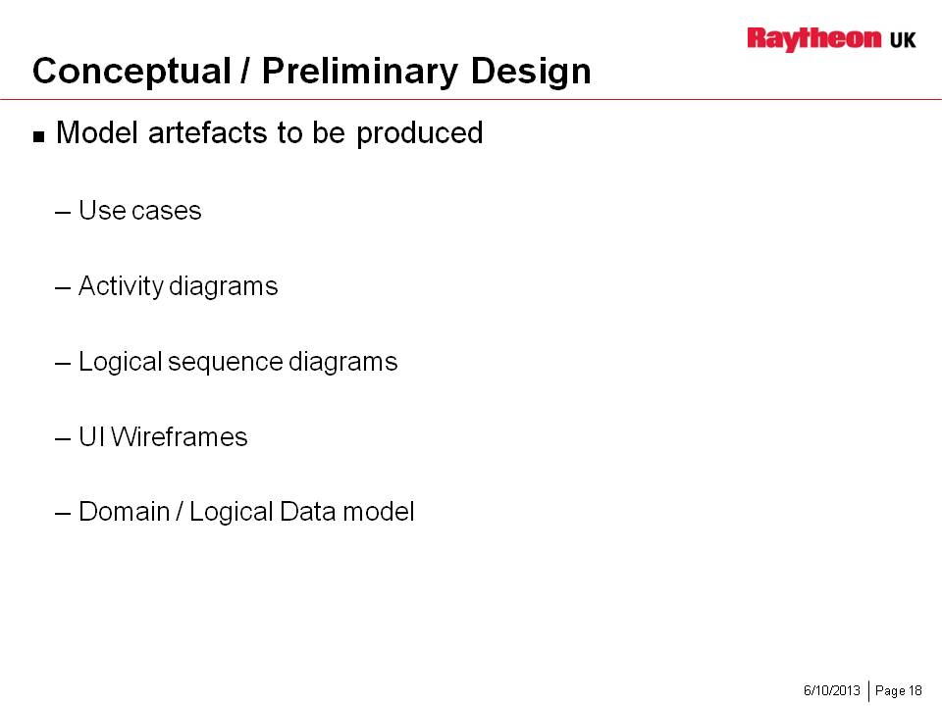

Notes

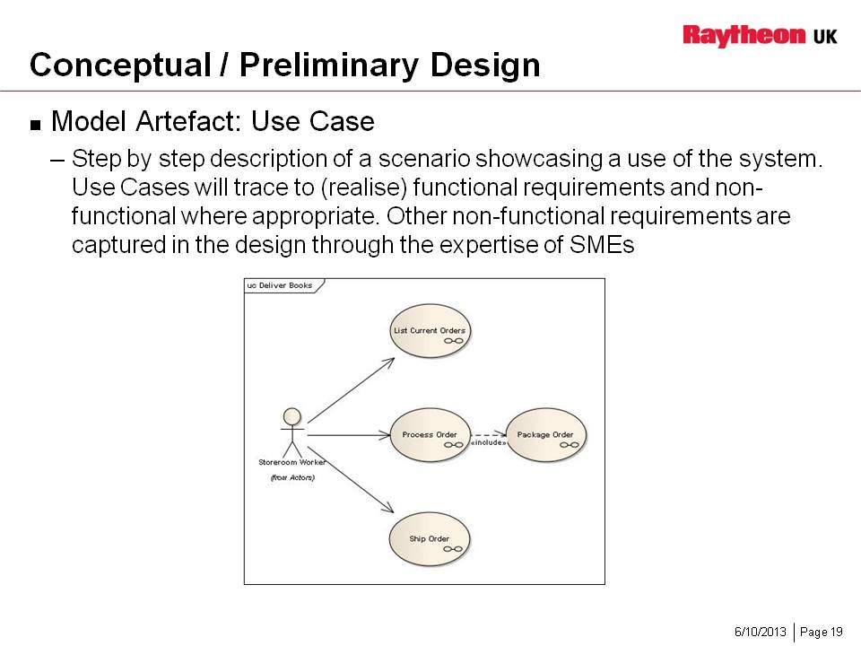

Notes

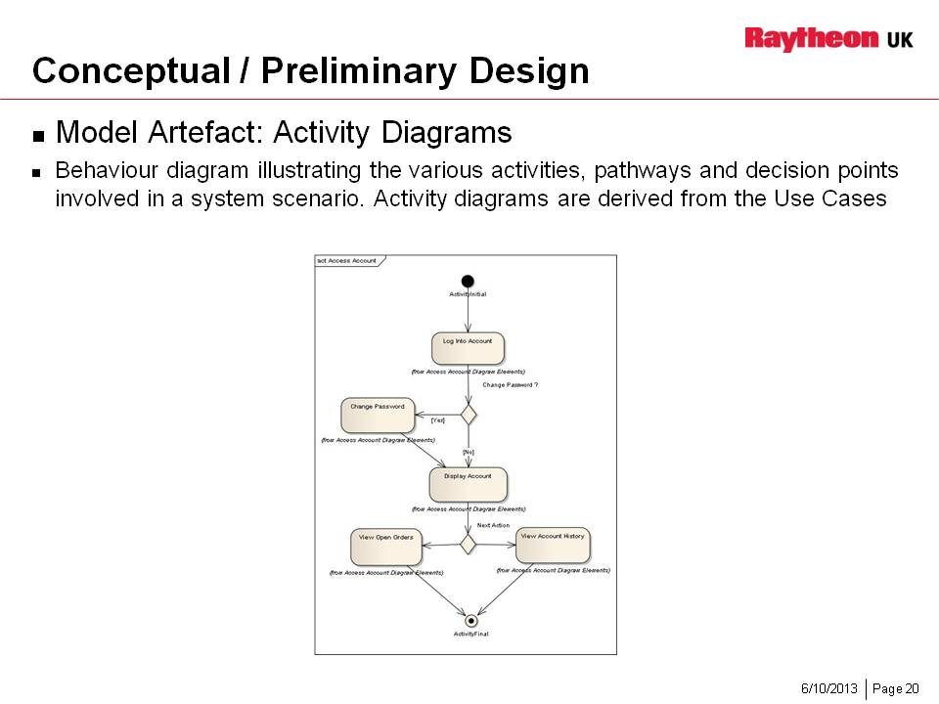

Notes

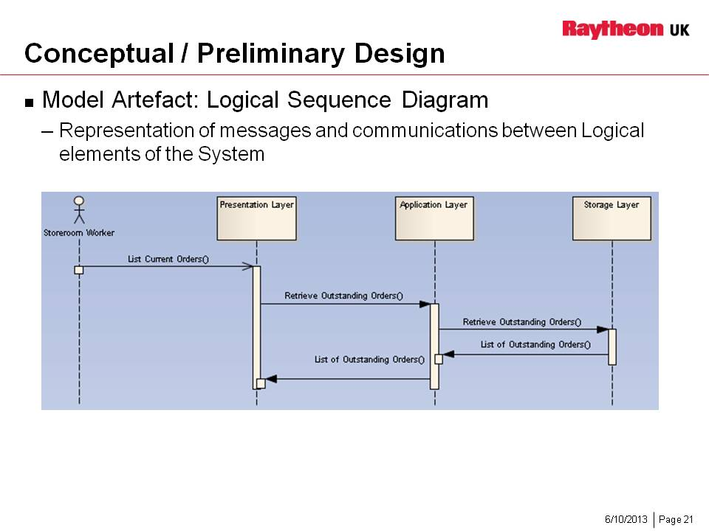

Notes

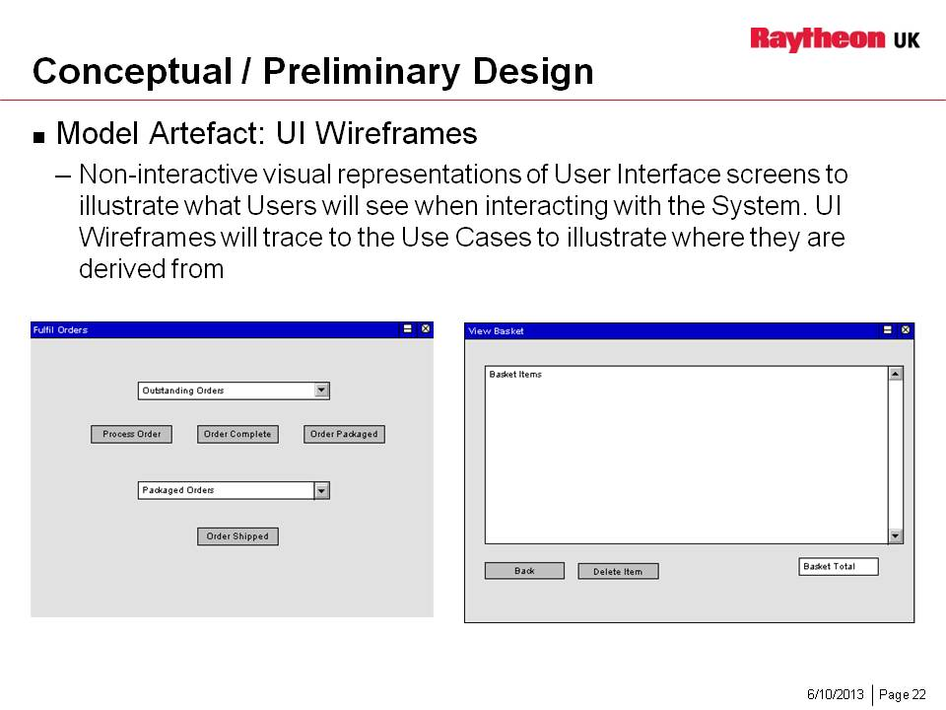

Notes

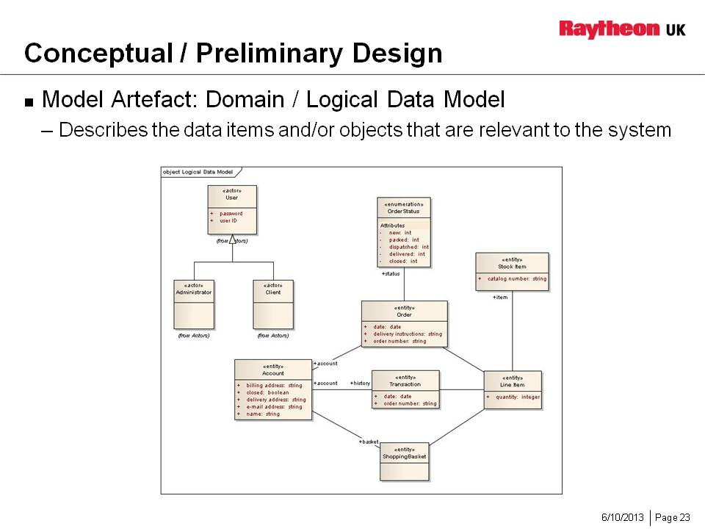

Notes

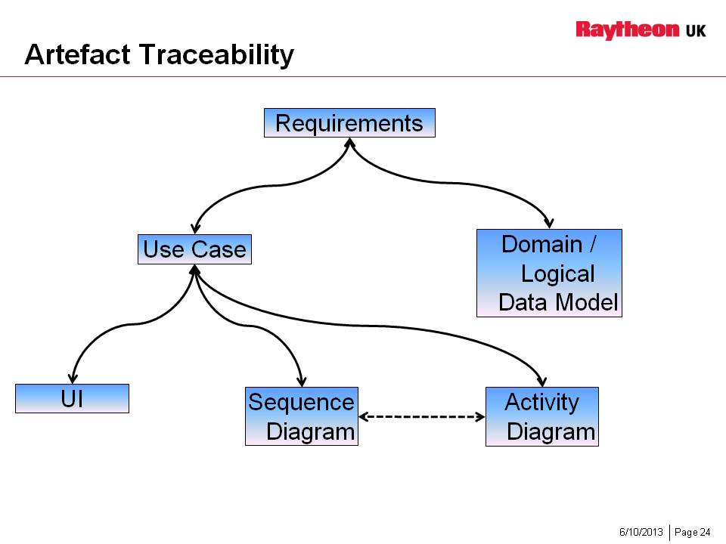

Notes

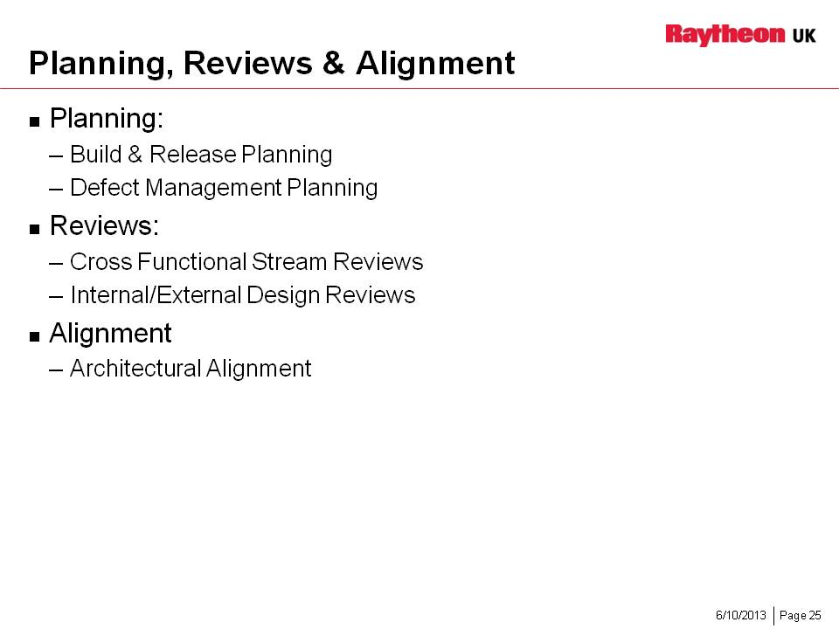

Notes

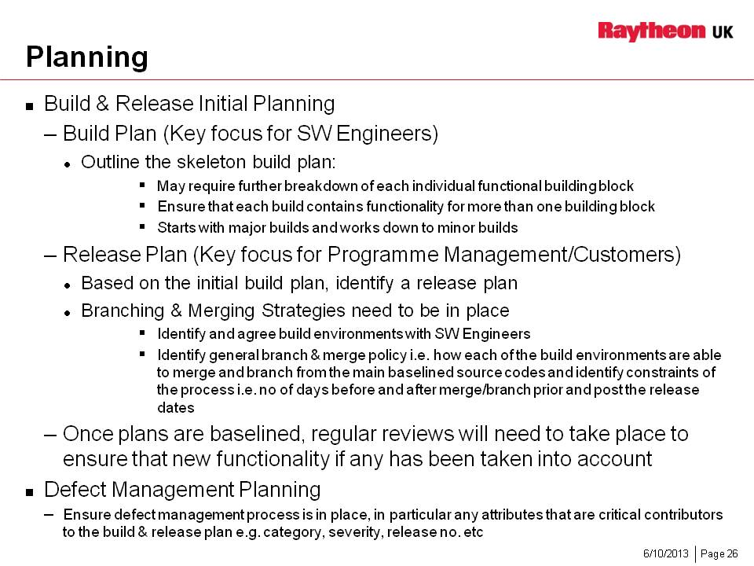

Notes

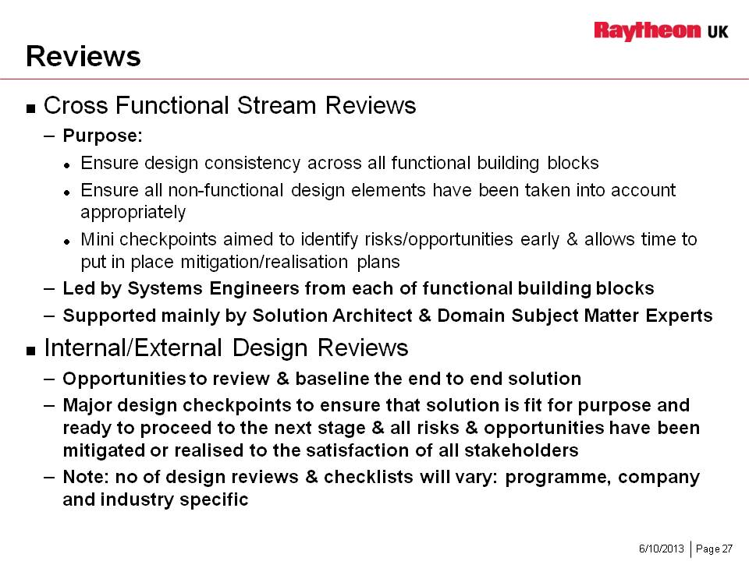

Notes

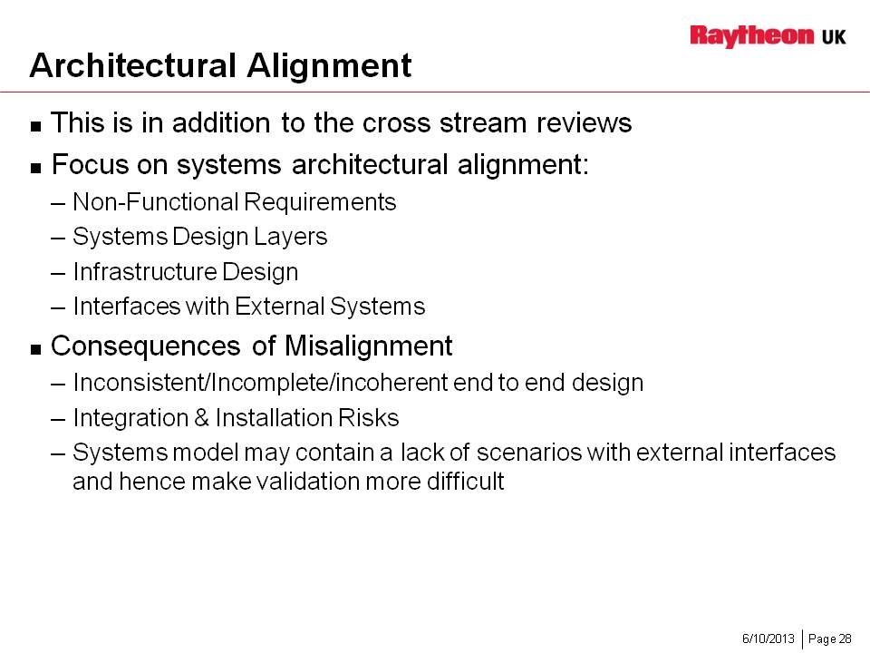

Notes

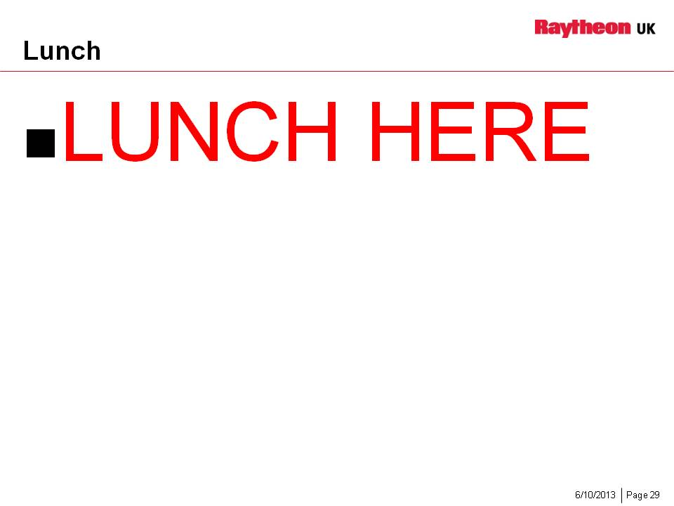

Notes

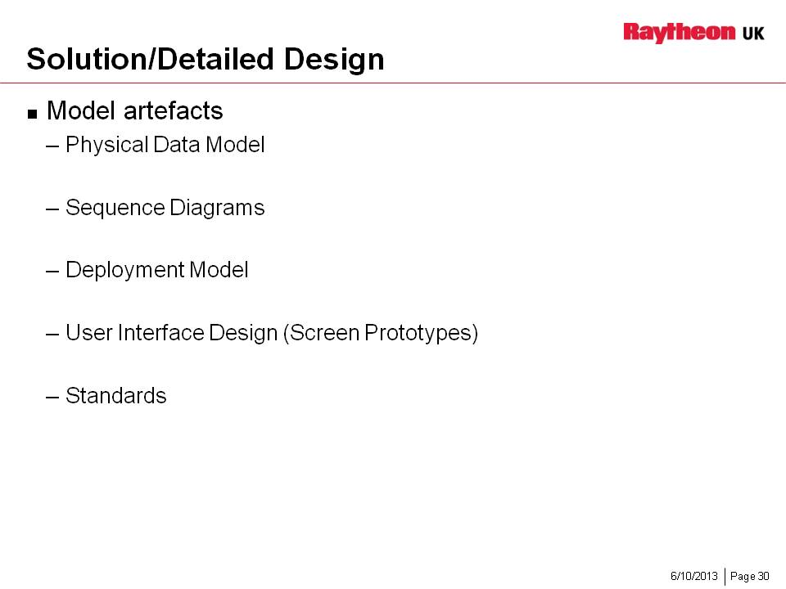

Notes

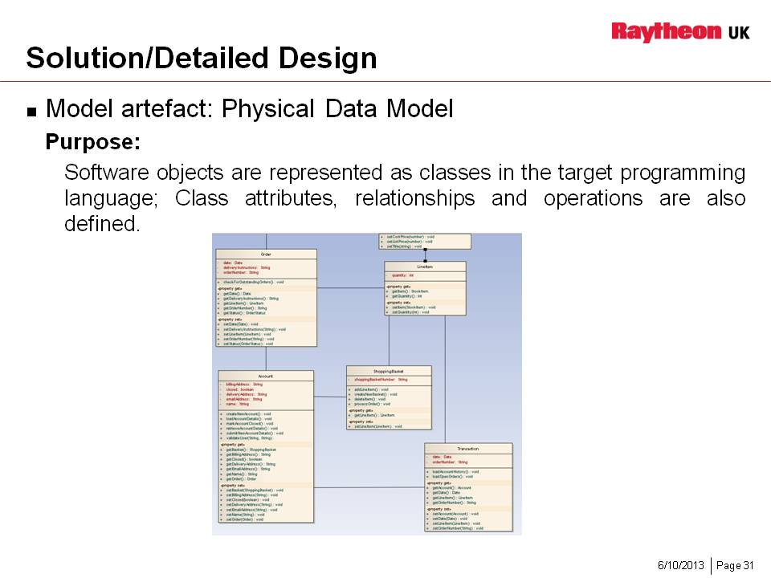

Notes

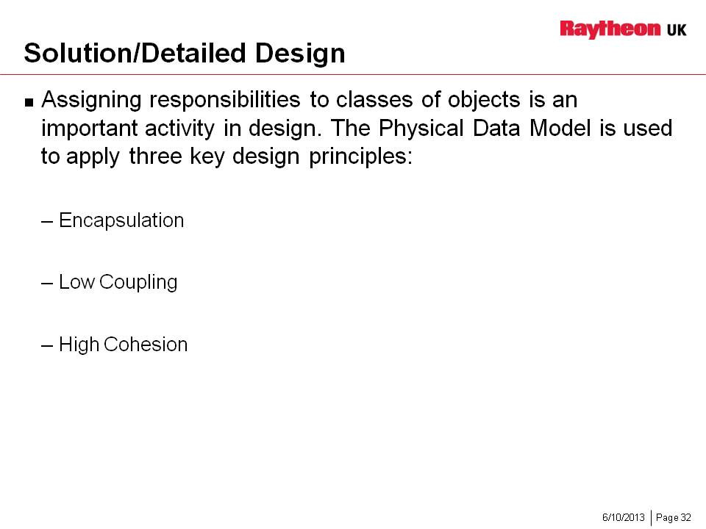

Notes

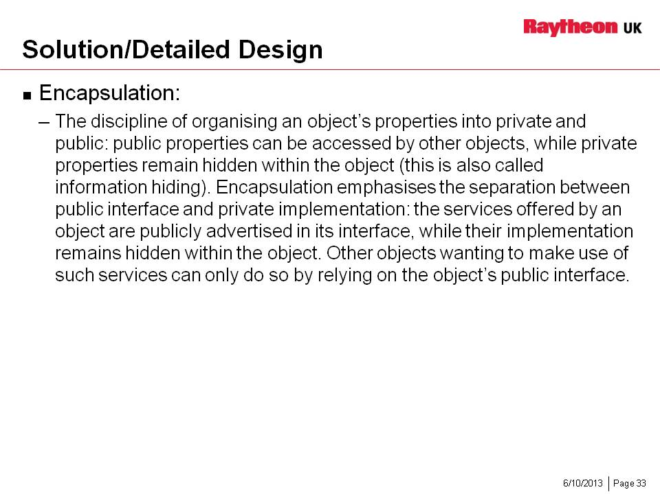

Notes

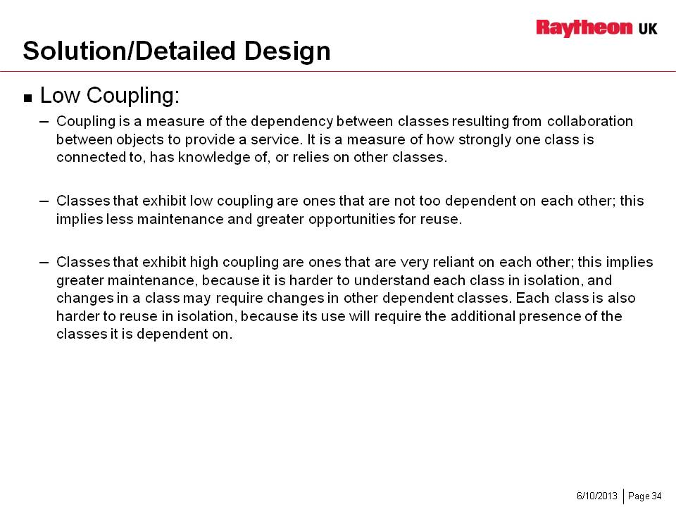

Notes

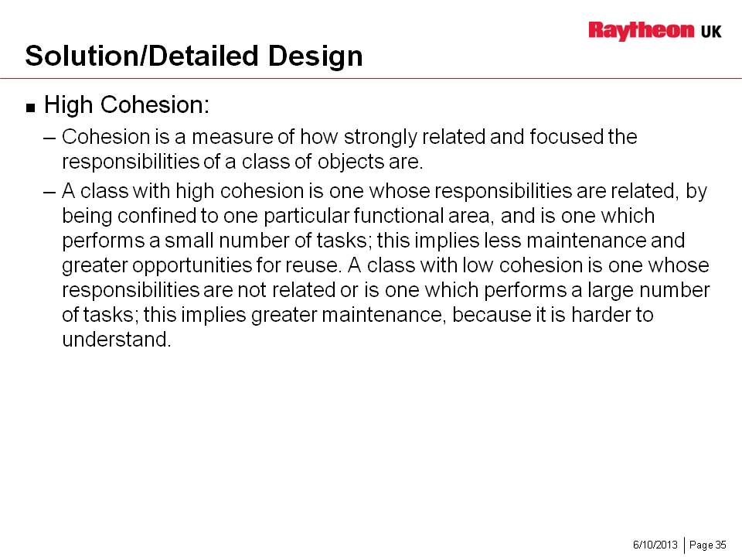

Notes

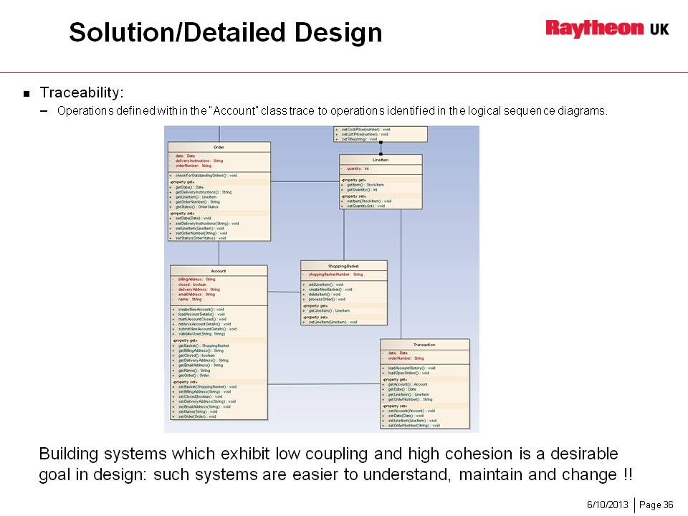

Notes

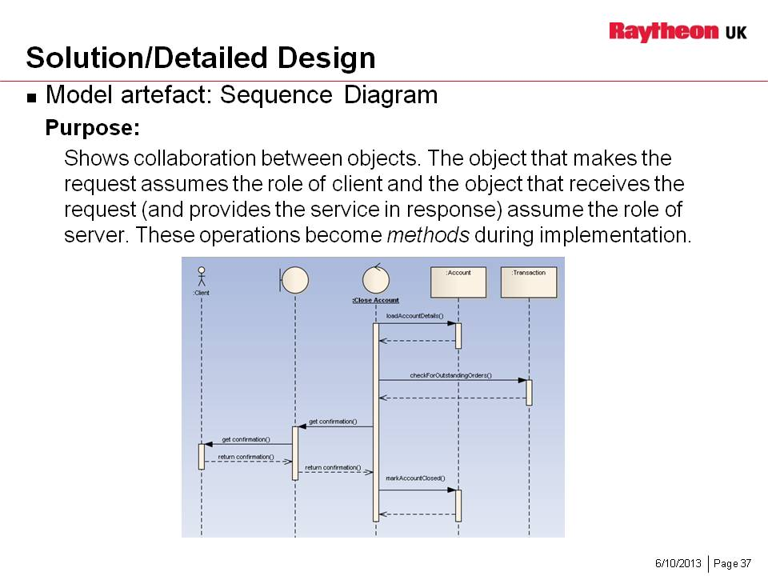

Notes

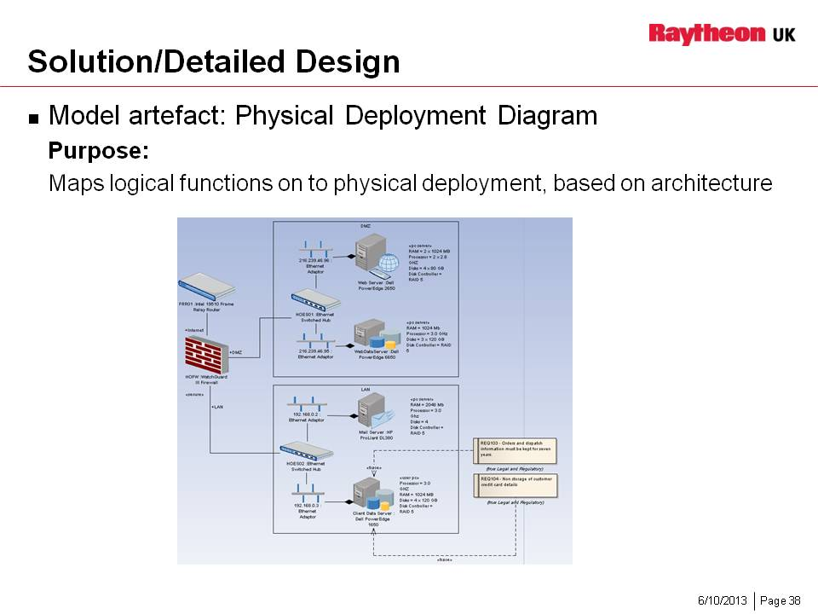

Notes

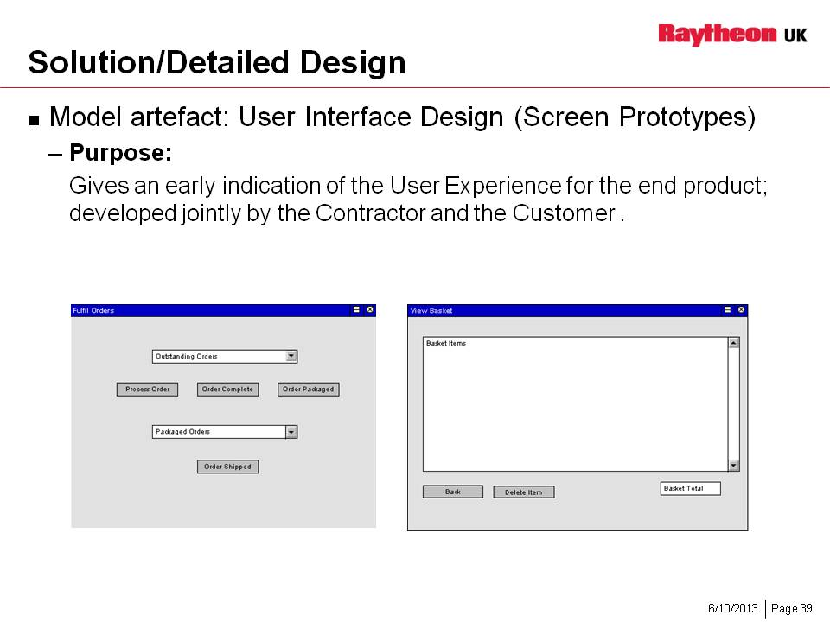

Notes

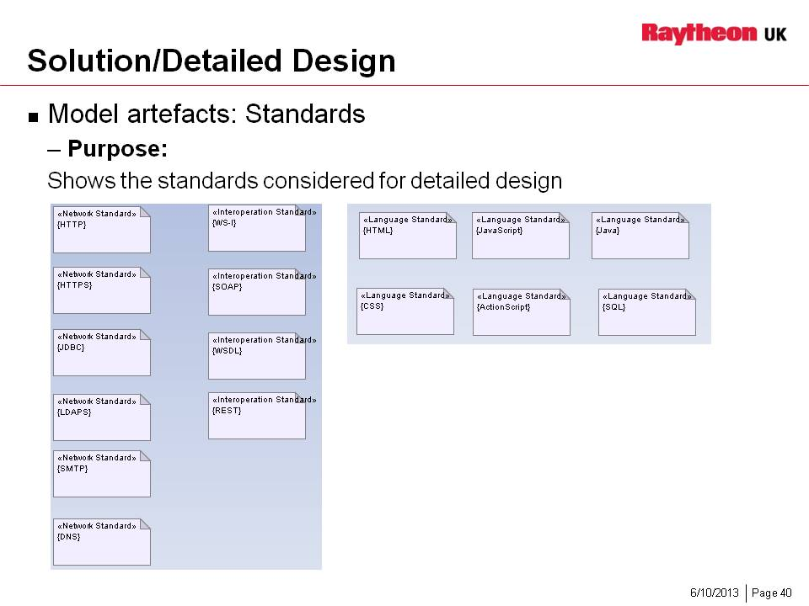

Notes

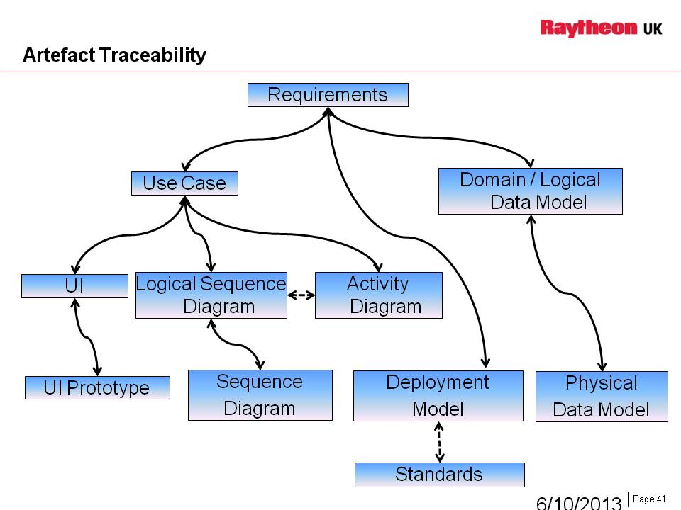

Notes

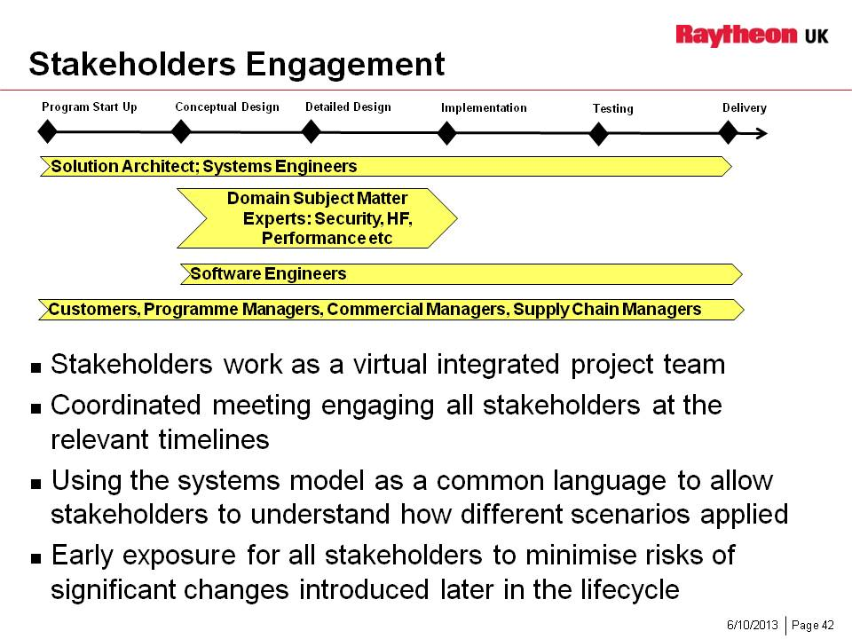

Notes

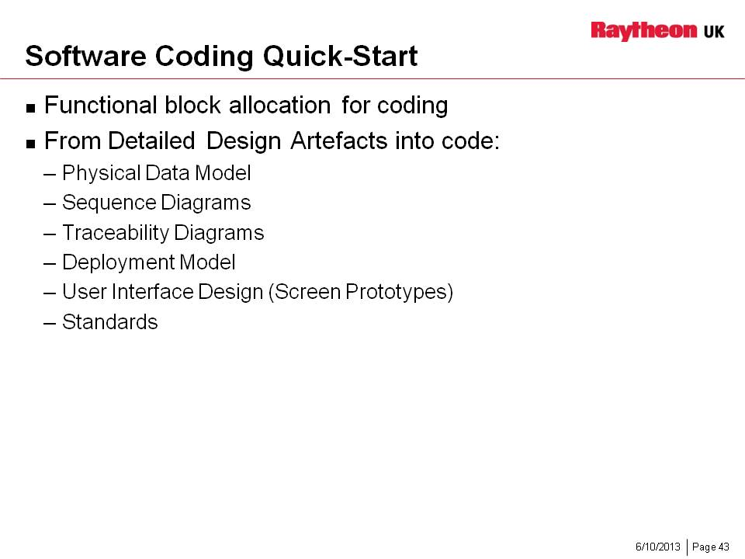

Notes

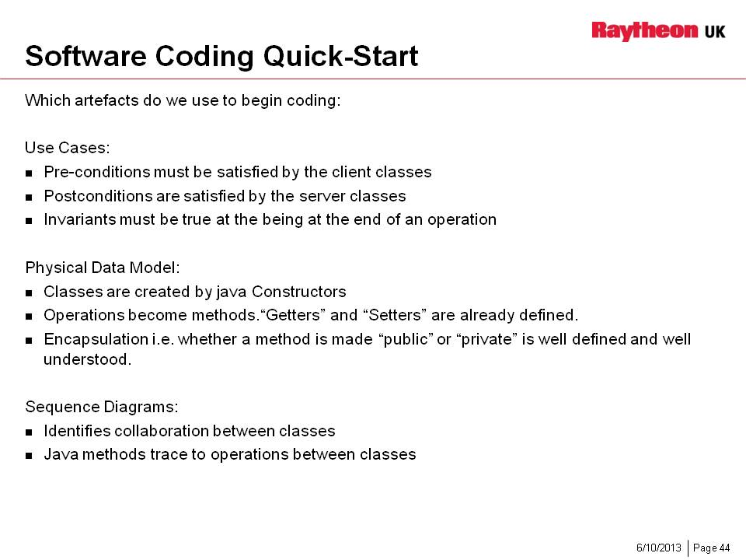

Notes

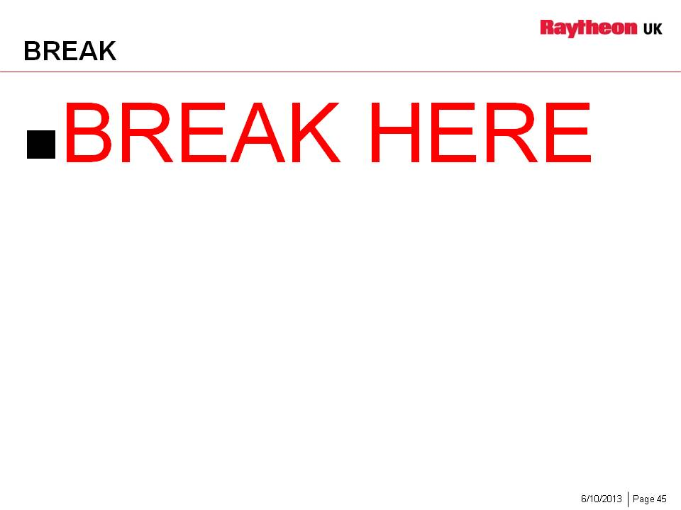

Notes

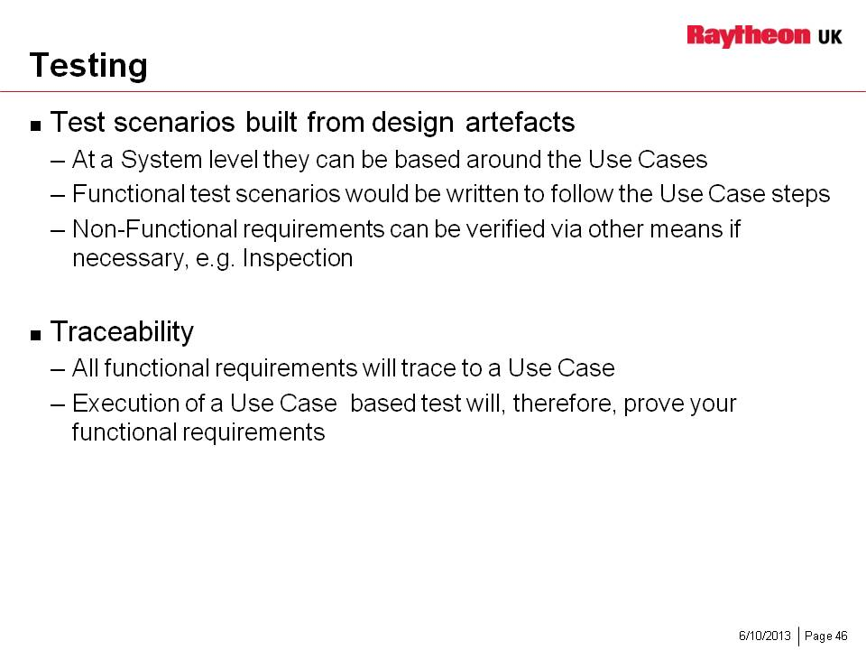

Notes

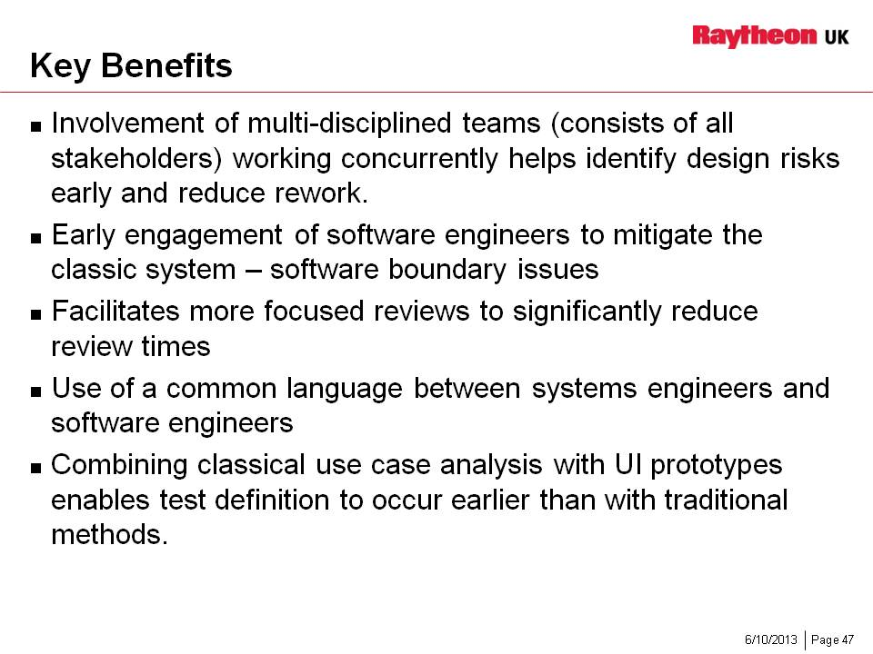

Notes

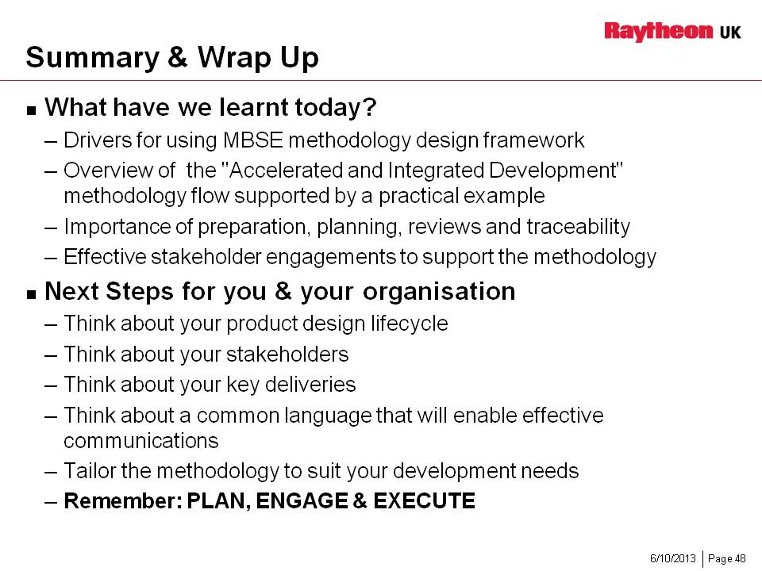

Notes

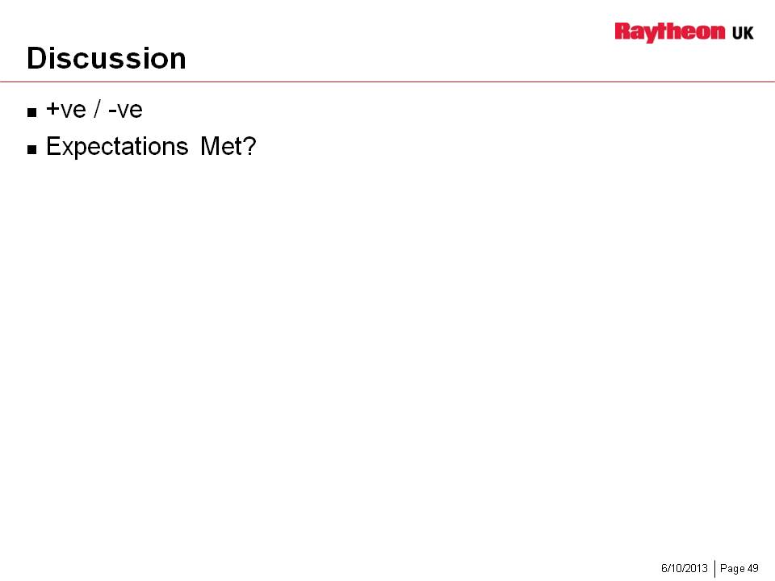

Notes

Accelerated and Integrated Development (AID) Methodology Diagram

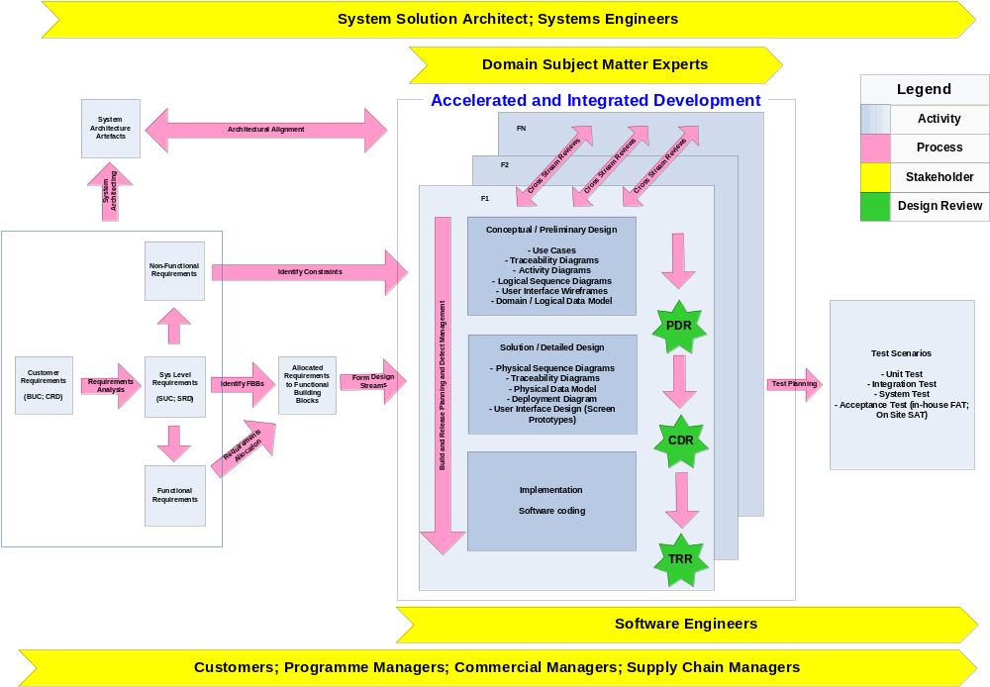
Blank page

Example Artefacts: i.e. Use Cases, Activity Diagram, Sequence Diagram, Domain/Data Model, UI Wireframes

Conceptual Design

Requirements
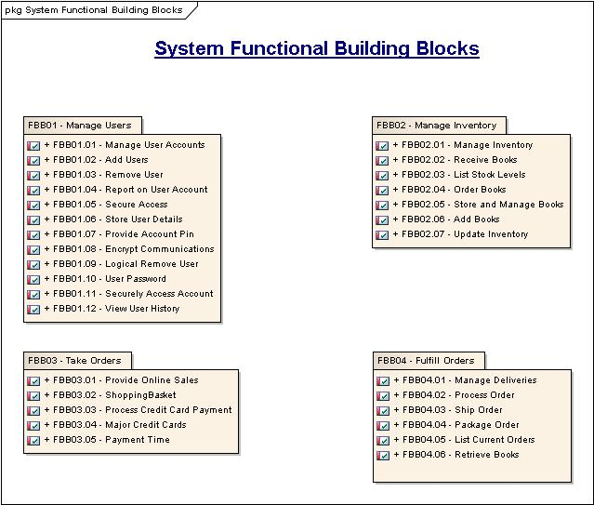
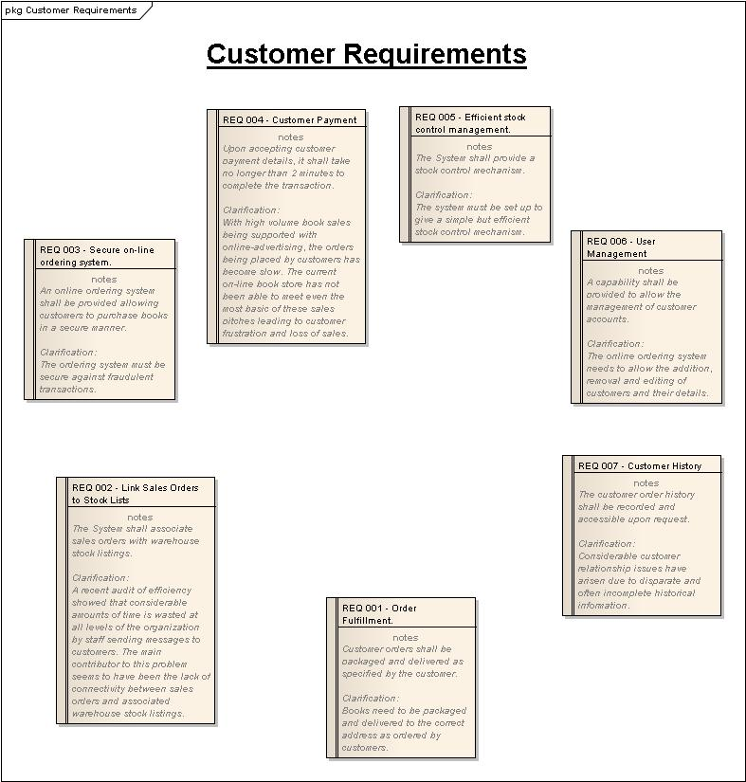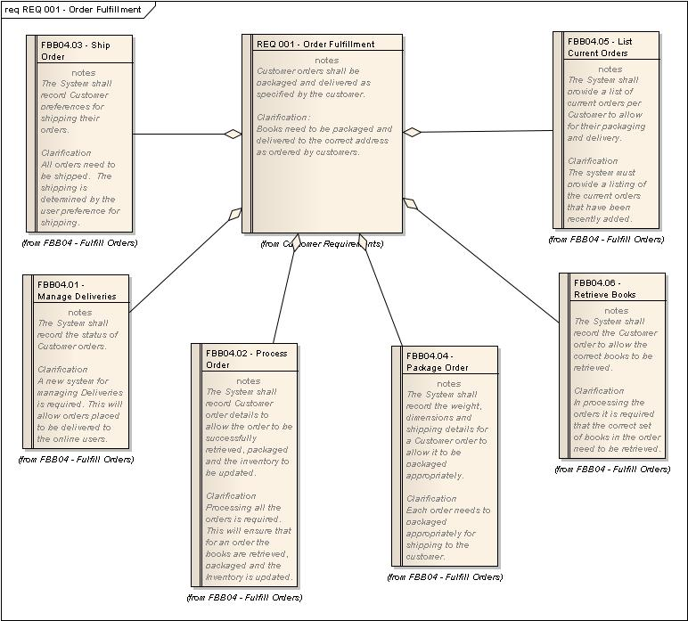

Use Cases
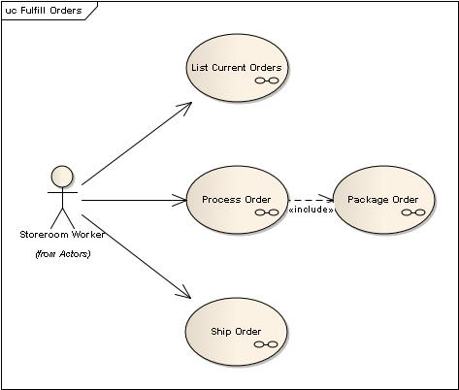

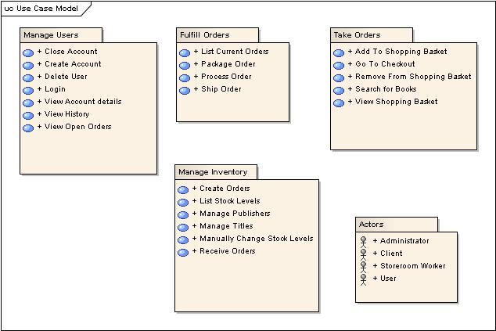

Data Models
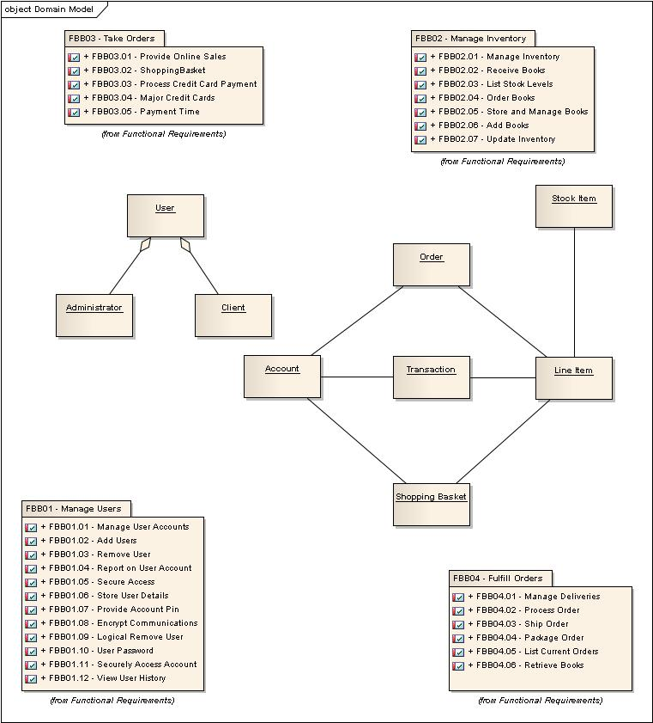

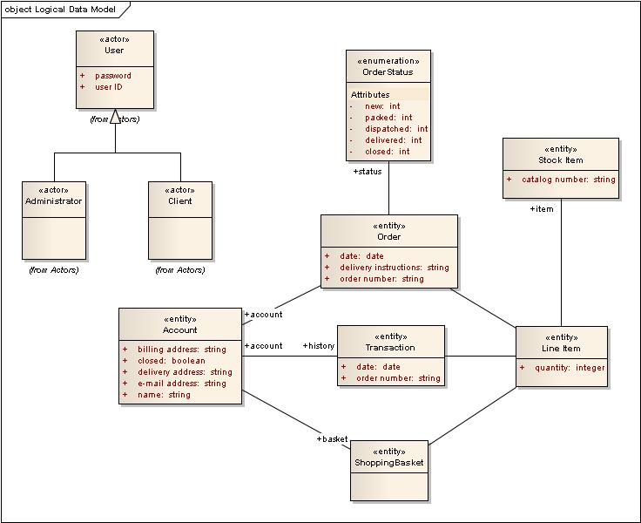

Activity Diagram
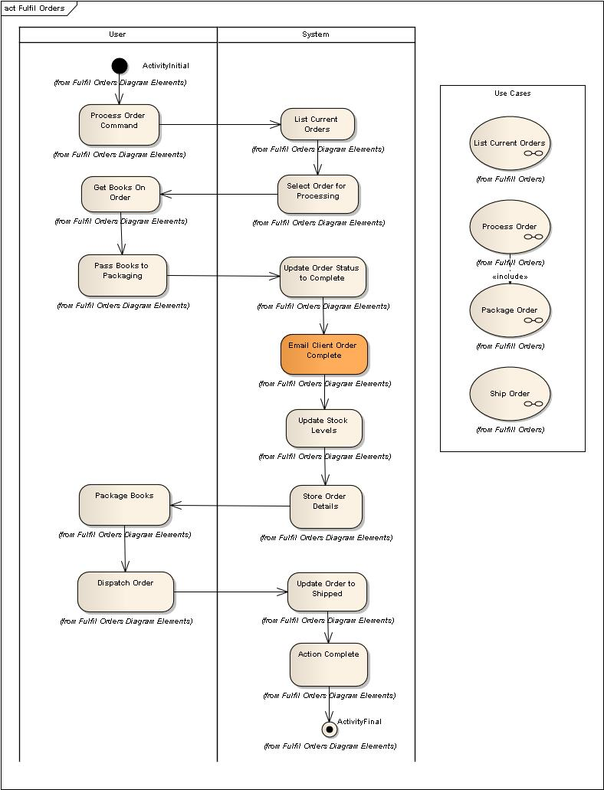

Logical Sequence Diagrams
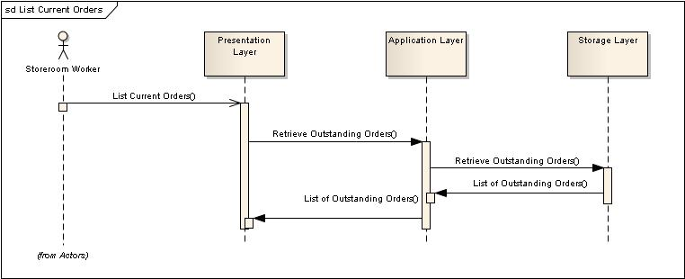

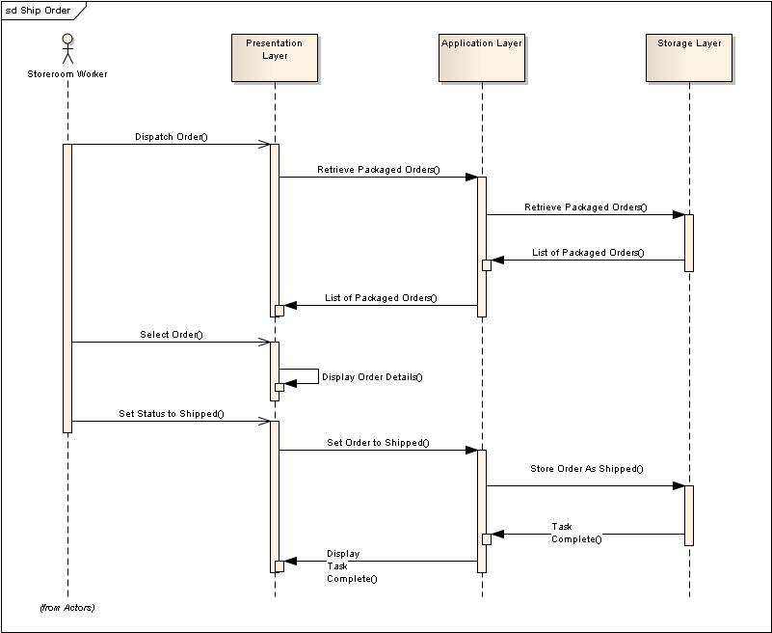
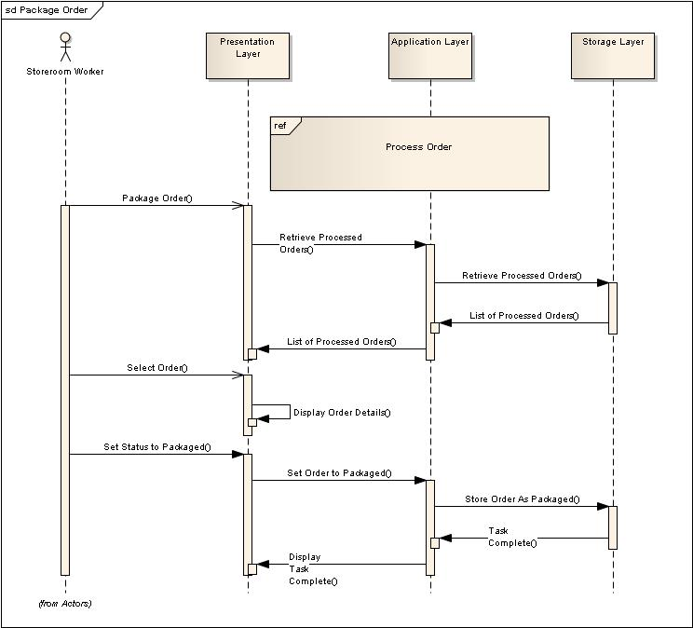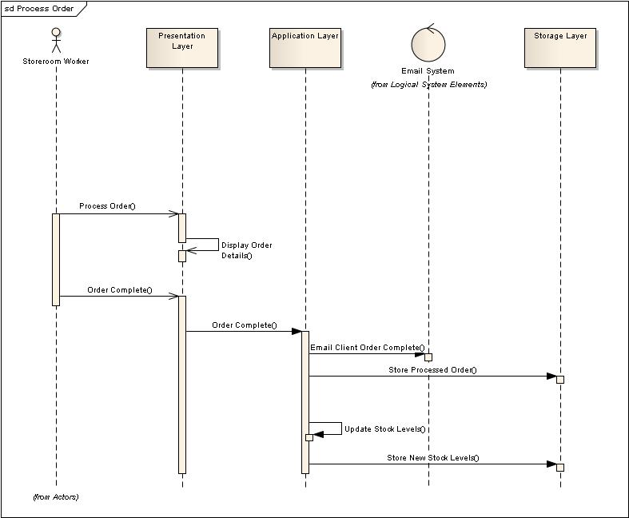

User Interface
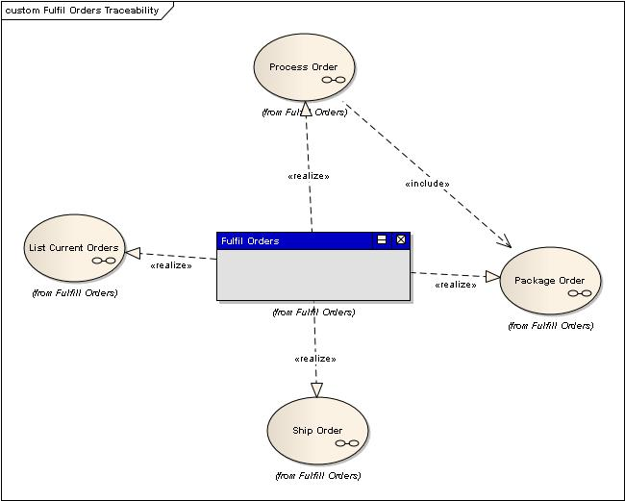
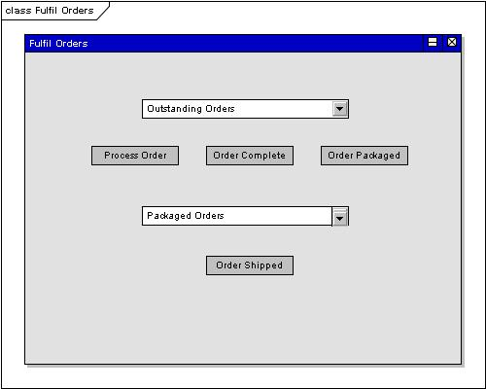

Solution Design

Physical Data Model
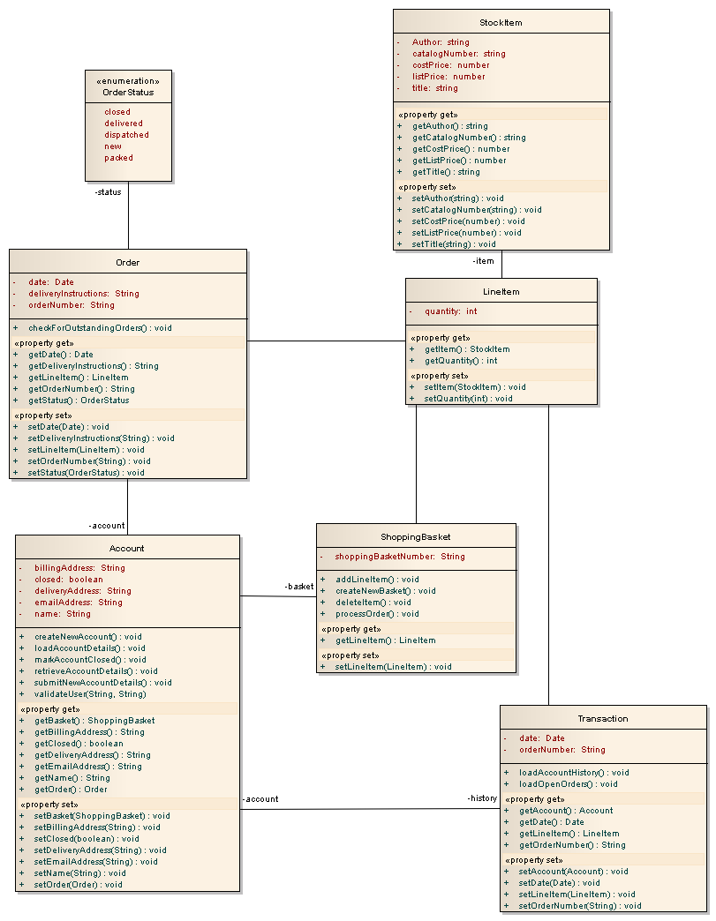

Sequence Diagram
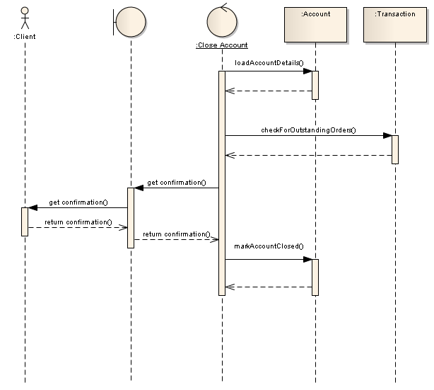

Deployment Model
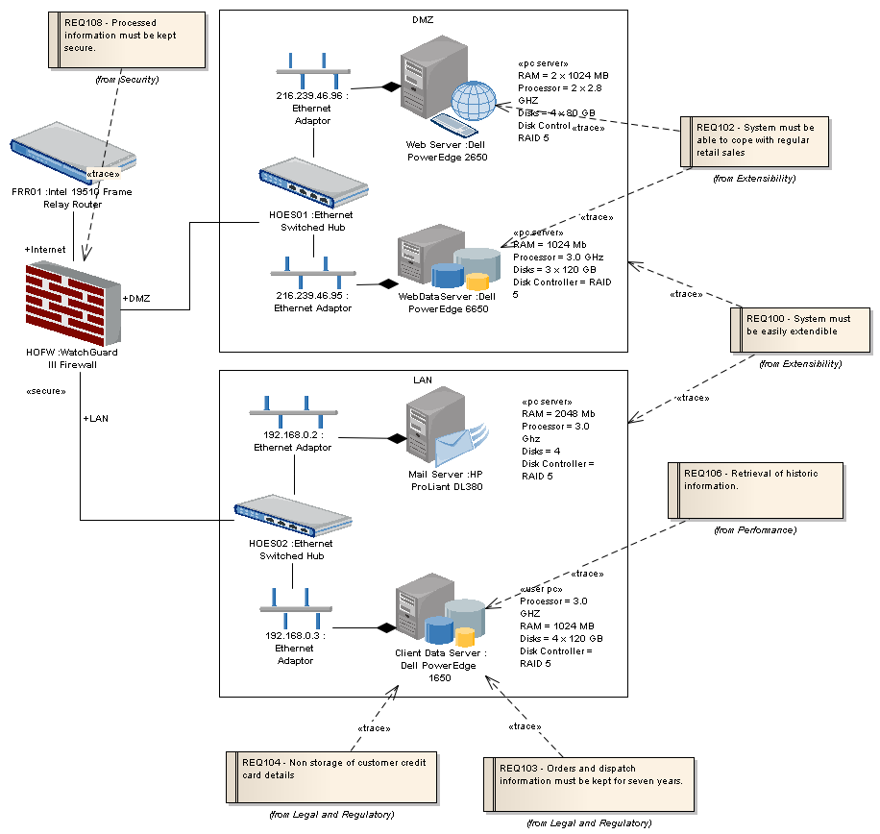

Standards View
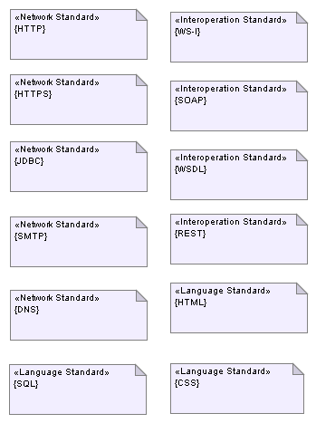

Glossary of Terms:
FBB - Functional Building Blocks
BUC - Business Use Case
SUC - System Use Case
CRD - Customer Requirements Document
URD – User Requirements Document
SAT - System Acceptance Test
FAT - Factory Acceptance Test
SME - Subject Matter Expert
UI - User Interface
Non-functional Requirements
PDR – Preliminary Design Review
CDR – Critical Design Review
TRR – Test Readiness Review.

References
Cockburn, A. (2001) Writing Effective Use Cases, Addison-Wesley.
Satzinger, J., Jackson, R., and Burd, Stephen D. (2010), Systems Analysis and Design in a Changing World, Course Technology.
Larman, C. (2002) Applying UML and Patterns: an Introduction to Object-Oriented Analysis and Design (2nd edition) Prentice Hall.
McBreen, P. (2000) Test Cases from Use Cases, http://www.mcbreen.ab.ca/papers/ TestsFromUseCases.html [accessed 02.04.2013].
Object Management Group website http://www.uml.org/ [accessed 02.04.2013].

Biographies of Presenters:
Felicity Fashade
Felicity is the Head of Systems Engineering for Raytheon UK. She is responsible for the deployment of SE resources, tools and processes across all RTN UK sites. Felicity joined Raytheon in 2008 as a Senior Systems Engineer for a large software based programme and subsequently became the Software Build and Release Manager.
She became the Engineering Transformation Lead in 2011, where she is instrumental in formulating strategies and implementing process improvement initiatives for the engineering function. Prior to Raytheon, she spent 11 years at the missile division of BAE Systems in the areas of guidance and control and systems engineering.
Felicity has a BEng(Hons) degree in Electrical and Electronics Engineering from Brunel University and is a Chartered Engineer. She also gained a MBA in Engineering Management in 2005. She lives in North London and is married with two children.
Philip Wilson
Philip Wilson is a Senior Systems Engineer and Section Manager at Raytheon UK. He provides SE expertise across the system lifecycle on a number of programmes, and also performs other related activities including independent reviewing, acting as a process improvement champion and mentoring of graduates.
Philip joined Raytheon in June 2008, prior to which he had been with Selex SAS from March 1999, a company which he joined as an engineering graduate. Philip’s engineering experience is wide ranging, covering aspects such as capture engineering, requirements management, formal customer reviews, IV&V, UML modelling, tools administration, and working in fields such as electronic warfare, homeland security and corporate litigation.
Philip has a BSc(Hons) in Aerospace Systems Engineering and is a member of the IET.
Paul Lowe
Paul is a Senior Systems Engineer at Raytheon UK. He joined as part of the Integrated Logistic Support (ILS) group in 2001, specialising in Reliability and Maintainability (R&M) of air traffic management systems, where he became Lead R&M engineer on a major programme for the National Air Traffic Service (NATS). Paul has worked on several software based programmes, designing enterprise I.T. solutions for military and civilian customers.
Paul’s technical experience spans the system lifecycle, from requirements capture to in-service support. He has expertise in availability and performance modelling, requirements management and UML. Paul has also developed and delivered training in IT system administration and object-oriented design principles.
Paul has a BEng(Hons) degree in Electronic Engineering, is ITIL certified and is a Professional Member of the BCS.

Name and contact details of the presenters

Felicity Fashade
Head of Systems Engineering
Engineering Transformation Lead
Raytheon UK
Raytheon Company
+44 (0) 1895 816228 (business)
+44 (0) 7918731810 (mobile)
+44 (0) 1895 814829 (fax)
Felicity.Fashade@raytheon.co.uk
9th Floor, Harman House,
1 George Street,
Uxbridge, Middlesex, UB8 1QQ, United Kingdom.

Philip Wilson
Uxbridge Engineering Section Manager / Senior Systems Engineer
National Security
Raytheon UK
Raytheon Company
01895 816288 (business)
07764 897037 (mobile)
phil.wilson@raytheon.co.uk
9th Floor, Harman House,
1 George Street,
Uxbridge, Middlesex, UB8 1QQ, United Kingdom.

Paul Lowe
Project P OS&M Technical Subcontract Manager/Senior Systems Engineer
Defence Intelligence Systems
Raytheon UK
Raytheon Company

01279 407315 (business)
07961 083003 (mobile)
paul.a.lowe@raytheon.co.uk
The Pinnacles,
Harlow,
Essex, CM19 5BB, United Kingdom.

